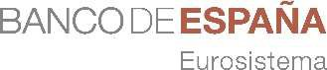

8TH ANNUAL RESEARCH CONFERENCE
ECONOMICS OF ARTIFICIAL INTELLIGENCE
Madrid, 13 and 14 November 2025

Hemiciclo 11
Thursday, 13 November 2025

9:15- 9:30

9:30-11:30
Welcome address
Deputy Governor Soledad Núñez (Banco de España)
1

SESSION 1

MONETARY POLICY 1 MODELLING TOPICS
Chair: Giuseppe Bruno (Banca d'ltalia)

Estimating nonlinear heterogeneous agent models with neural networks
Authors: Hanno Kase (ECB), Leonardo Melosi (EUI) and Mattias Rottner (BIS)

Speaker: Leonardo Melosi (European University lnstitute) Discussant: Vytautas Valaitis (University of Surrey)

Monetary policy with persistent supply shocks
Authors: Galo Nuño (Banco de España), Philipp Renner (University of Lancaster) and Simon Scheidegger (HEC Lausanne)

Speaker: Simon Scheidegger (HEC Lausanne) Discussant: Oreste Tristani (ECB)

11:30 - 12:00 I Coffee break

12:00 - 13:00
KEYNOTE SPEECH

Deep Learning in Economics: A Geometric lnterpretation
Jesus Fernández Villaverde (University of Pennsylvania)

13:00 - 14:30 1 Lunch

14:30 - 16:30
SESSION 2

PRODUCTIVITY AND LABOUR MARKET
Chair: Luis Servén (Council Member, Banco de España)

The rapid adoption of generativa Al
Authors: Alexander Bick (Federal Reserve Bank of St. Louis), Adam Blandin (Vanderbilt University) and David Deming (Harvard Kennedy School)

Speaker: Alexander Bick (Federal Reserve Bank of St. Louis) Discussant: Christina Gathmann (LISER)

Al and the labor market
Authors: Mennaka Hampo/e (Ya/e SOM), Dimitris Papanikolaou (Kellogg School of Management), Lawrence D.W. Schmidt (Sloan School of Management MIT) and Bryan Seegmiller (Northwestern University)

Speaker: Dimitris Papanikolaou (Kellogg School of Management) Discussant: Ana Lamo (European Central Bank)

16:30 - 17:00 1 Coffee break

17:00-18:00
SESSION 3

PRODUCTIVITY AND LABOUR MARKET
Chair: Luis Servén (Council Member, Banco de España)

Artificial intelligence in the knowledge economy
Authors: Enrique /de (/ESE) and Eduard Ta/amas (/ESE)

Speaker: Eduard Talamas (IESE)
Discussant: Luis Garicano (London School of Economics)

Hemiciclo 11
Friday, 14 November 2025

9:00 - 11:00
SESSION 4

FINANCIAL STABILITY
Chair: José Maria Serena (OG Financial Stability, Banco de España)

lnstitutional asset pricing, segmentation, and inequality
Authors: Goutan Gopalakrishna (University of Toronto), Zhouzhou Gu (Princeton University) and Jonathan Payne (Princeton University)

Speaker: Jonathan Payne (Princeton University) Discussant: Riccardo Cioffi (París School of Economics)

Artificial intelligence and relationship lending
Authors: Leonardo Gambacorta (BIS), Fabiana Sabatini (Banca d'ltalia) and Stefano Schiaffi (Banca d'ltalia)

Speaker: Leonardo Gambacorta (BIS) Discussant: Gianmarco Ruzzier (Banco de España)

11:00 - 11:30 I Coffee break

11:30-13:30
SESSION 5

MONETARY POLICY 2 INFLATION FORECASTING ANO COMMUNICATION
Chair: Mayte Ledo (OG Strategy, Peop/e and Data, Banco de España)

Simulating the SPF
Authors: Anne Lundgaard Hansen (Federal Reserve Bank of Richmond}, John J. Horton (MIT Sloan School of Management), Sophia Kazinnik (Stanford HA/), Diana Puzzello (Indiana University Bloomington) and A. Zarifhonarvar (Indiana University Bloomington)

Speaker: Sophia Kazinnik (Stanford University HAI) Discussant: Joan Paredes (National Bank of Slovakia)

Word2Prices: Embedding central bank communications for inflation prediction
Authors: Douglas Arauja (BIS}, Nikola Bokan (ESM), Fabio A. Comazzi (ECB) and Michele Lenza (ECB)

Speaker: Michele Lenza (ECB)
Discussant: Michael McMahon (University of Oxford)

13:30 - 15:00 1 Lunch, end of conference

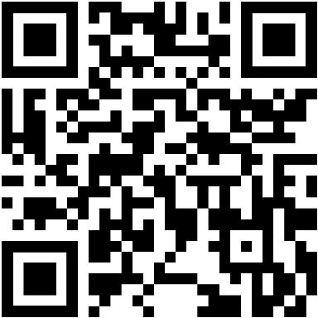
Código Wifi

